Temporal analysis of fuzzy c-means clustering for global data
between 2020 and 2024

Gherasim Delia-Catalina
Applied Computational Intelligence
Group 246-1

Abstract

This paper analyzes the global impact of the Covid-19 pandemic between 2020 and 2024 using fuzzy c-means (FCM) clustering to find the relations between health, economy and social well-being. We examined four datasets from varying domains: global Covid-19 reports, company layoffs, international logistics and economic indicators and the World Happiness Report. FCM allowed us to see transitions between clusters and capture overlapping trends. The analysis revealed that pandemic progression varied across countries due to healthcare infrastructure and political response. Layoffs showed different peaks based on company size, the most significant occurring in late 2022 and early 2023. Economic indicators revealed phases of disruption and recovery, and happiness levels did not show correlation with the pandemic. Because FCM allows for partial membership between clusters it revealed efficiently real-world trends.

Table of Contents

Abstract 1
I. Introduction 3
II. Theoretical aspects: Fuzzy C-Means clustering 4
1. Cluster analysis 4
2. Clustering algorithms 4
III. Overview of the datasets 6
1. Daily COVID-19 Data 6
2. Layoffs 6
3. Global logistics and economic indicators 7
4. World happiness report 7
IV. Data preprocessing 9
V. Data analysis using FCM clustering 12
1. Daily COVID-19 Data 12
2. Layoffs 15
3. Global logistics and economic indicators 17
4. World happiness report 19
VI. Reporting and evaluation 21
VII. Conclusions 24
References 24

Introduction

Relevance of the chosen topic
The first cases of the Covid-19 outbreak started in the Wuhan region of China in December 2019. The virus spread rapidly, such that on March 11th, 2020, the World Health Organization declared it a global pandemic. Beyond the serious physical effects, the virus caused psychological distress and economic instability. There is no denying that the disease has left its mark on the whole world as one of the darkest times in recent history.

Motivation
By understanding the pandemic’s full impact through analysis of health outcomes, economic and social indicators, we can acknowledge how different countries were affected and how they adapted over time.

Objectives
The aim of this paper is to analyze the effects of the virus world-wide, between 2020 and 2024, looking at topics such as: virus statistics, economic indicators, reported layoffs and overall happiness. This will be achieved by applying the fuzzy c-means clustering method to four different datasets, encompassing a wide range of topics. The four datasets contain global time-series information, offering an overall view of the pandemic years. This method will help identify shared patterns and gradual transitions between countries and time periods.

Contributions
This work provides a data analysis of the pandemic period using fuzzy clustering, in order to showcase the shared patterns across the globe. In the following section, we will describe the theoretical aspects behind fuzzy c-means clustering. Chapter III presents an overview of the used datasets, with an emphasis on their utility, while Chapter IV presents the data preprocessing performed for each. Chapter V contains the main data analysis and FCM experiments, Chapter VI evaluates the results with cross-domain comparisons and is followed by the conclusion.

Acknowledgement:
This work is the result of my own activity, and I confirm I have neither given, nor received unauthorized assistance for this work.
I declare that I used generative AI or automated tools in the creation of content or drafting of this document. I used Gemini to summarize my initial notes and correct the logical flow as well as to proofread my final draft and correct the grammar.
All the text impacted by generative AI has been explicitly marked as such in this document.

Theoretical aspects: Fuzzy C-Means clustering

Cluster analysis

Data analysis represents the software task of processing large volumes of data. Cluster analysis is used in order to group unlabeled data based on similarity. Data clustering is a data analysis technique, appliable in pattern recognition, data mining or machine learning, most importantly in data classification (Ghosh, 2013). The data used in clustering can be numerical, categorical or both. A cluster is a partition of unlabeled sets of data based on similarity. In clustering analysis, similarity is measured by a small relative distance between data points. Clusters can be spherical and elongated or hollow, the last two representing linear or nonlinear subspaces of the data. The objective of clustering is identifying underlying patterns in the data. (Balasko, 2005) The use of this method assumes that there exists an order in a seemingly unordered dataset, even if the specific group memberships are not known. Even more, cluster analysis can be used as a data reduction approach in order to create a simplified version of the dataset. (Döring, 2006)

Clustering algorithms

Clustering algorithms can generally be divided into hard or fuzzy, depending on the lenience with which the data is divided into clusters. In other words, hard clustering does not allow a data object to belong to more than one cluster, while fuzzy clustering allows different degrees of membership. (Balasko, 2005)

K-Means
K-Means clustering is a data analysis method that treats the input data as points with varying distances. The data is split into K mutually exclusive clusters such that objects within a cluster are as close as possible to each other, but as far away as possible from other clusters. The centroid of a cluster is its center point, and is the characteristic point computed by averaging the coordinates of the other points in the cluster. (Ghosh, 2013)

The main steps of the algorithm are:
  - Select the number of clusters K
  - Choose K initial points to serve as the starting cluster centroids
  - Assign each data point to the closest centroid’s cluster
  - After all points are assigned, compute new centroids for each cluster
  - Repeat steps 3 and 4 until no data points change and the centroids are stable

Mathematically, let the dataset be represented as $X=\left\{x_{1}, x_{2}, …x_{n}\right\},{ x}_{k}∈R^{d}$,

where n is the total number of data points and d is the number of dimensions.
For a selected number of clusters c such that 1< c< n, the K-Means algorithm is:
- Initialization: choose c data points from X to serve as the initial cluster centroids vi
- Distance computation: for each $x_{k}$, determine its squared Euclidean distance from each centroid:
$D_{ik}^{2}={\left(x_{k}-v_{i}\right)}^{T}\left(x_{k}-v_{i}\right), 1≤i≤c, 1≤k≤n$
- Cluster allocation: assign each data point $x_{k}$ to the cluster with the smallest distance
- Centroid recalculation: update each cluster center by computing the mean position of all cluster points $v_{i}^{l}=\frac{1}{n_{i}}\sum_{j=1}^{n_{i}}{x_{j}}$
- Convergence condition: repeat the previous two steps until the centroids no longer change (Balasko, 2005)

The time complexity of the algorithm, using squared Euclidean distances, is $O(ncdi),$where n = number of data points, c = number of clusters, d = number of dimensions and i = number of iterations. (Ghosh, 2013)

K-means is effective when applied to datasets that are normally distributed and do not contain outliers, as it relies on the mean value to define cluster centroids, therefore it performs well for continuous and evenly distributed data. (Lund, Performance Measurement and Metrics)

K-medoids
Unlike K-means, which computes centroids based on the mean of all points within a cluster, K-Medoids selects actual data points as representative centers. This makes it more robust to extreme values and irregular distributions and is suitable for datasets with discrete or categorical tendencies and when outliers are not relevant.

Fuzzy C-Means
The Fuzzy C-Means algorithm is a clustering method in which each data point can belong partially to multiple clusters. In K-Means clustering, a point belongs only to one cluster, but in Fuzzy C-Means clustering, each data point can belong to multiple clusters with varying degrees.

It derives from fuzzy c-partitions, which can be mathematically described as follows:
- Let $X=\left\{x_{1}, x_{2}, …x_{n}\right\}$ be a dataset of n points, where each point $x_{k}$ is a vector in $R^{p}$ and $p$ is the number of features. 2.
- Considering $U=[u_{ik}]$ the $c×n$ membership matrix, where $u_{ik}$ represents the degree, from 0 to 1, to which the data point $x_{k}$ belongs to cluster $i$. The stronger the membership to a cluster, the closer to 1.
- The set $M_{fc}^{n}$ represents the fuzzy c-partition space and defines all possible membership matrices $U$ that satisfy the rules: $u_{ik} ∈\left[0,1\right]$
$\sum_{i=0}^{c}{u_{ik}}=1$
$0< \sum_{i=0}^{c}{u_{ik}}<n$

In this algorithm, each data point is represented by a membership value for each cluster, between 0 and 1, indicating the strength of association. All membership values for each data point must add up to one, ensuring that its total association is distributed among the clusters. Each cluster must have at least some and not all data points, in order to prevent empty or dominant clusters. The main goal of FCM is to find the best cluster centers and memberships that minimize the overall distance between data points and cluster centers. The algorithm starts with random assigning and updates the cluster centers and memberships until the changes are insignificant, resulting in overlapping clusters that reflect fuzzy boundaries between groups in the data. (Paragraph written with the help of generative Ai)
(Nascimento, 2000)

Overview of the datasets

The selected datasets have been chosen in order to present an overview of the world during the 2020 – 2024 period. They cover a wide range of topics: health, economy, logistics and happiness, in a global context. All four datasets are from https://www.kaggle.com/datasets .

Daily COVID-19 Data

https://www.kaggle.com/datasets/abdoomoh/daily-covid-19-data-2020-2024?select=WHO-COVID-19-global-data.csv

This data has been gathered from the World Health Organization (WHO), which compiles weekly reports from national health authorities. It contains multiple files, but for the purpose of this paper, we will use the daily reported Covid-19 cases and deaths by country, in order to analyze pandemic trends. Possible analysis includes growth rates and peaks in infections and deaths or regional comparisons.

Key attributes of the dataset are:

Date_reported | Country_code | Country | WHO_region | New_cases | Cumulative  _cases | New_  Deaths | Cumulative  _deaths
date | text | text | text | numeric | numeric | numeric | numeric
dd-mm-yyyy | the ISO country code | the full country name | a four-letter WHO region code | new cases reported at the specific date | cumulative cases until that date | new deaths reported until that date | cumulative deaths until that date

Layoffs

https://www.kaggle.com/datasets/theakhilb/layoffs-data-2022

This dataset has been collected from Layoffs.fyi and documents global layoff events from 2020 to 2024. The dataset is usefull in analysis of unemployment trends during the pandemic and post-pandemic years because it reflects real-time labor market issues. It can be used in studying sector-specific layoff trends, geographic patterns of workforce reductions and post-pandemic restructurings. Because the data is scraped and not official, small companies may be under-represented.
Company | Location_HQ | Industry | Laid_Off_Count | Date | Source | Funds_  Raised | Stage | Date_  Added | Country
text | text | text | numerical | Date  Yyyy-dd-mm | text | numerical | text | Date  Yyyy-dd-mm | text
It contains the columns:

Global logistics and economic indicators

https://www.kaggle.com/datasets/nabilalagi/global-logistics-and-economic-indicators-2020-2024

This dataset covers daily observations from January 1st 2020 to May 17th 2024, highlighting global supply chain and economic conditions. It includes measures for shipping rates, Brent oil prices and the Global Supply Chain Pressure Index. These indicators help track logistical pressures and the energy market throughout the period. The dataset reflects the effects of geopolitical events such as the Russia-Ukraine war or the Suez Canal blockage more accurately than the other datasets, although it is primarily focused on global indicators and not country-level supply chains.

It includes the following columns:
- Date: date YYYY-MM-DD
- Global_Container_Index_FBX: numeric, USD
- China_US_West_Coast_Route: numeric, USD
- US_West_Coast_China_Route: numeric, USD
- China_North_Europe_Route: numeric, USD
- North_Europe_China_Route: numeric, USD
- Brent_Oil_Price_USD: numeric, USD
- GSCPI_Index: numeric
- Year : numeric
- Month : numeric
- Day_Of_Week: The day of the week (0=Monday, 6=Sunday)

The China_US_West_Coast_Route, US_West_Coast_China_Route, China_North_Europe_Route and North_Europe_China_Route describe the cost in US dollars of shipping a 40-foot container on the described route, while Global_Container_Index_FBX is the global average of shipping a 40-foot container over 12 major trade lanes. The Global Supply Chain Pressure Index or GSCPI_Index integrates various transportation and manufacturing metrics to provide a comprehensive gauge of global supply chain stress. A higher value means more stress.

World happiness report

https://www.kaggle.com/datasets/samithsachidanandan/world-happiness-report-2020-2024
Country Name |  | Happiness Rank |  | Happiness Score |  | Upperwhisker |  | Lowerwhisker
text |  | numerical |  | numerical |  | numerical |  | numerical
Economy (GDP per Capita) | Social support |  | Healthy life expectancy |  | Freedom to make life choices |  | Generosity |  | Perceptions of corruption
numerical | numerical |  | numerical |  | numerical |  | numerical |  | numerical

The World Happiness Report, published by the UN Sustainable Development Solutions Network, evaluates quality of life globally using surveys. This data presents country-level happiness rankings and scores, along with factors contributing to well-being. It offers a psychological perspective on global conditions during the pandemic, as well as showing the relationship between economic factors, public trust and happiness. This data is limited, having only yearly reports, and less frequent compared to the other datasets.

These four datasets enable an analysis of the global impact of Covid-19 through multiple points of view. The pandemic not only influenced public health but also economic activity, employment and population well-being. Combining these sources allows for a better understanding of recovery patterns across countries between 2020 and 2024.

Data preprocessing

In order to scale the data, Min-Max Scaling was applied for numerical features for all datasets. Min-Max scaling prevents extreme values from dominating clustering and ensures smooth transitions, which is suited for temporal datasets. Because this scaling bounds features between 0 and 1, it preserves relative differences and works well with distance-based clustering like FCM.
Categorical variables were encoded using one-hot encoding because clustering algorithms based on Euclidean distance require numerical inputs with no arbitrary order. One hot encoding converts each category into a binary column, ensuring no artificial ordering and equal contribution of categories. Other encoding methods would introduce artificial relationships between categories, which would mislead the clustering algorithm.

- Daily COVID-19 Data

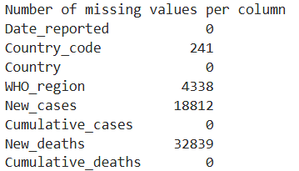
In order to prepare the WHO-COVID-19-global-data Dataset for FCM clustering we performed date format converting, data aggregation, outlier processing and variable scaling. The initial dataset had the following information:
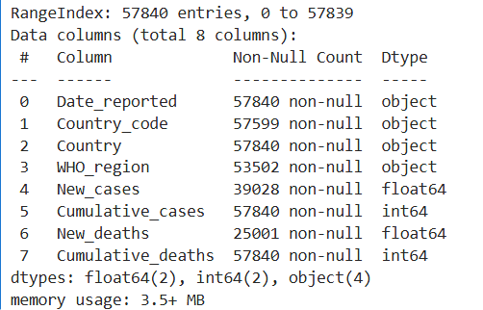

In the first pre-processing step we filled in the missing WHO_region values using a mapping of each country and its most frequent WHO region in the dataset. After that, the date was converted to a DateTime object and the rows were the date could not be parsed were dropped. The New_cases and New_deaths columns were filled by computing the difference between consecutive days, and the values that remained missing were set to 0. After which, the months were aggregated in order to obtain a monthly timestamp for each country of new deaths and cases, to reduce daily noise and simplify the trends for analysis.

We also computed new features that are usefull for tracking pandemic behavior: death rate and case growth rate. Using the Interquartile Range method, we identified the outliers in the columns: 'New_cases', 'New_deaths', 'Death_rate', 'Case_growth_rate', as these columns had fluctuating variables. The values below $Q1-1.5*IQR$ or above $Q3+1.5*IQR$ , where $IQR=Q3-Q1$ were clipped to those limits. Cumulative columns were left unchanged as they define the pandemic trajectory. In the last step, the columns 'New_cases', 'New_deaths', 'Cumulative_cases', 'Cumulative_deaths', 'Death_rate', 'Case_growth_rate' were scaled to the range 0-1. (Paragraph written with the help of generative Ai)
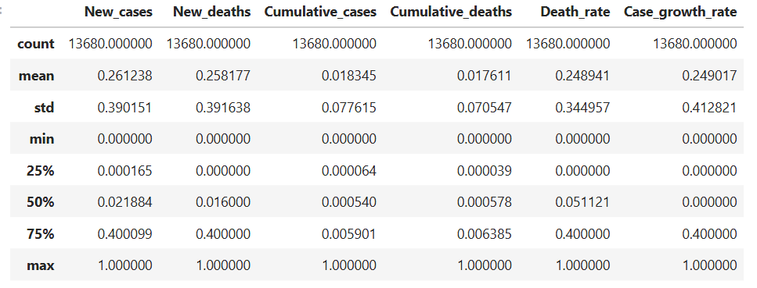

- Layoffs

The initial dataset contains 3642 entries and 11 columns, out of which the Laid_Off_Count, Funds_Raised and Percentage columns contain missing values.

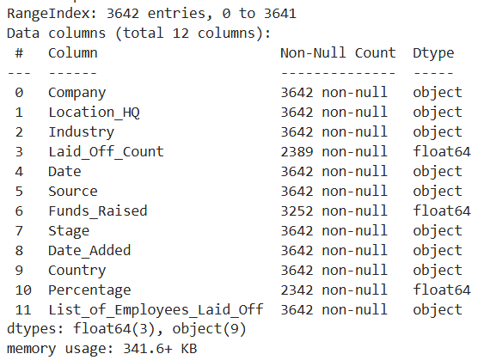
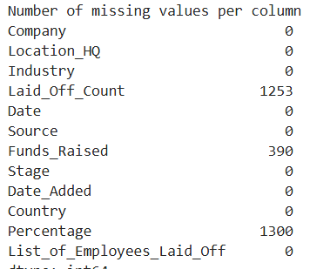

The first step of the data preprocessing is to handle missing values by filling missing values for the numerical columns 'Laid_Off_Count', 'Funds_Raised', 'Percentage' with a median in order to avoid biases from missing values. After which, we extract usefull features(month and year) from the dates and encode categorical values with one hot encoding. In the last step, we scale numerical features using MinMax Scaling and select the features for clustering.
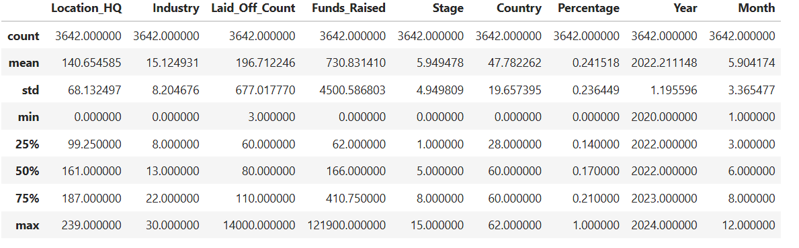
- Global logistics and economic indicators

The Global logistics and economic indicators dataset contains 1860 entries.
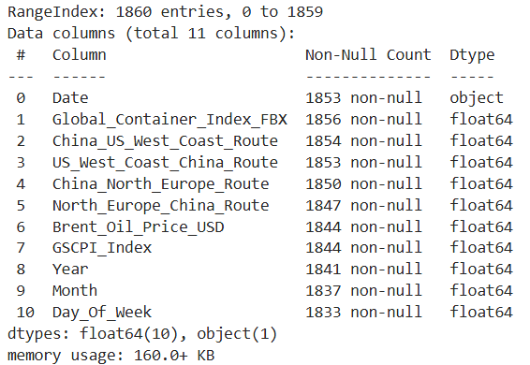
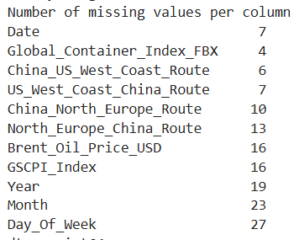

Before clustering, we apply several preprocessing steps such as handling missing values by filling the numeric columns with the column mean. To capture temporal trends, monthly averages were computed. Non-numeric columns were removed. The features were scaled to the 0-1 range using Min-Max scaling. The final dataset contains 52 monthly averages for each index.

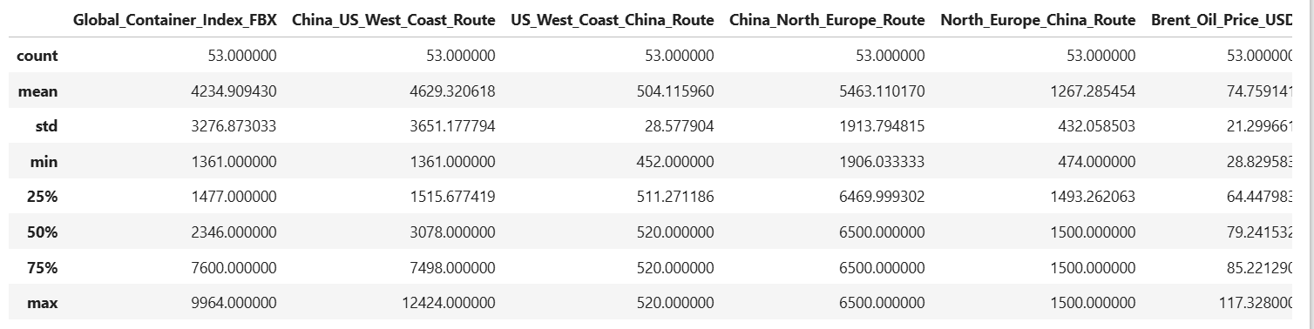

- World happiness report

The World Happiness Report dataset was comprised of different .csv files, one for each year from 2020 to 2024. Initially we merged the files, in order to obtain: 728 entries, one for each country-year combination. As part of the data cleaning, we handled missing values by dropping the rows where target features were missing and scaled the features using Min-Max Scaling. The final dataset had 724 entries.

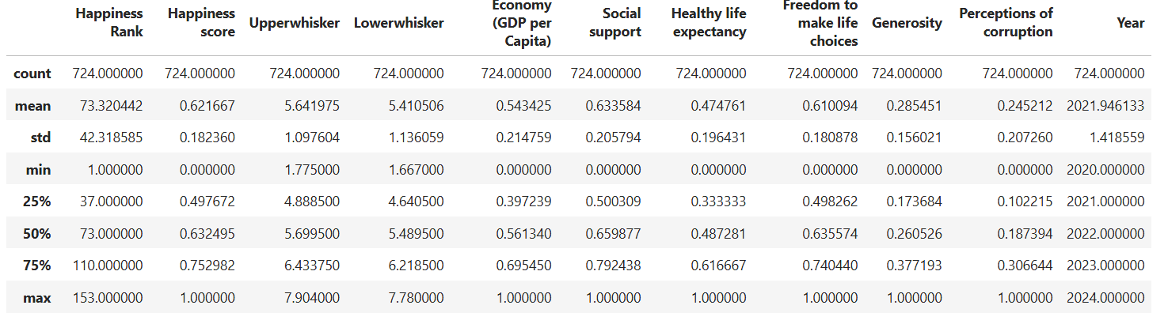

Data analysis using FCM clustering

Daily COVID-19 Data

To identify temporal pandemic progression patterns across countries, we conducted multiple FCM clustering experiments using the pre-processed monthly dataset. Due to FCM’s probabilistic cluster memberships, countries can belong to multiple clusters simultaneously, reflecting real-world pandemic spread.
The epidemiologic indicators used are the features: 'New_cases', 'New_deaths', 'Cumulative_cases', 'Cumulative_deaths', 'Death_rate' and 'Case_growth_rate'. These features show both short and long term disease characteristics. The dataset was transposed to meet the input requirements of the FCM algorithm, where each feature forms a row vector.
The algorithm generated cluster centers, the membership probability matrix and a fuzzy partition coefficient as a validity metric. The FPC score evaluates the fuzzy partition quality across clusters, where values closer to 1 indicate stronger separation and stability.
Cluster membership distributions were evaluated monthly to assess the global evolution of COVID-19 severity. Line visualization revealed evolving cluster participation, caused by variant waves, vaccination and varying public-health strategies. For each cluster, countries with the highest membership probability represent pandemic trajectory archetypes.

Fuzzy clustering was executed using the scikit-fuzzy library with the parameters:
- fuzzification coefficient: 2, 1.9, 1.8, 1.7, 1.6, 1.5
- maximum iterations: 1000,
- convergence tolerance: 0.005
- varying number of clusters: 3, 4, 5, 6, 7
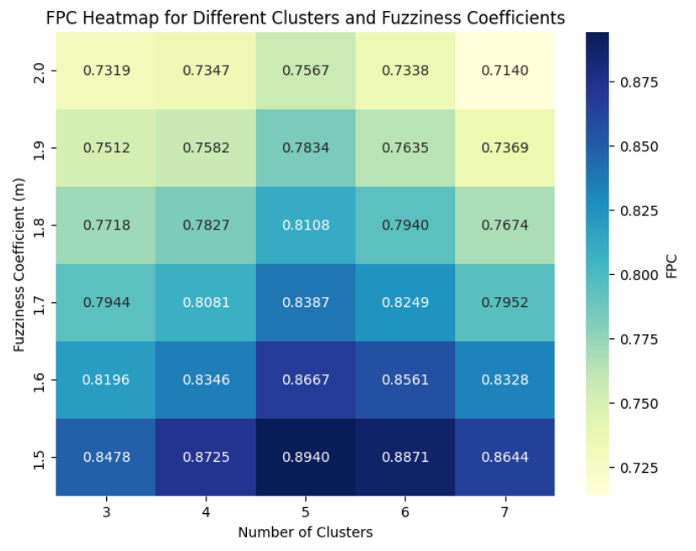
Model quality was assessed using the FPC. The fuzzification coefficient shows that a lower m results in a higher FPC, so a better segmentation of clusters.
The 3-cluster model distinguishes broad severity levels but oversimplified pandemic heterogeneity, the 4-cluster model improves separation among high-transmission countries. The 5-cluster solution suggests the best fuzzy partition, capturing intensity and structural differences in progression patterns. The 6 and 7 cluster solutions show a drop in FPC, indicating over-segmentation. Because of this, the 5-cluster model with fuzziness coefficient 1.5 was selected as the best one.
5-clusters and 1.5 fuzziness coefficient

This model had the best FPC score, showing the best partitioning. Each cluster represents a distinct Covid-19 pattern and reporting variation:
- Cluster 0: Very high new cases and deaths and a very fast case growth rate, with countries such as: Canada, Italy and Portugal. Most are developed countries with high testing capacity, which explains the large number of reported cases.
- Cluster 1: High cases and deaths but a slower growth rate. Included countries are Russia, UK, Chile and Spain. Most countries have hit a major wave and than faced a stable phase in the pandemic.
- Cluster 2: Low cases and high death rate, in countries such as: Jamaica, Bosnia and Herzegovina and Yemen. This may indicate underreporting of cases, a pattern typical for lower income countries
- Cluster 3: Moderate case and death numbers, but a high case growth rate. Countries that tend to experience short, intense waves such as small or isolated countries: Luxembourg, Malta, French Guiana.
- Cluster 4: This cluster shows very low levels, they are countries that had very few infections like Tokelau, or International commercial vessels

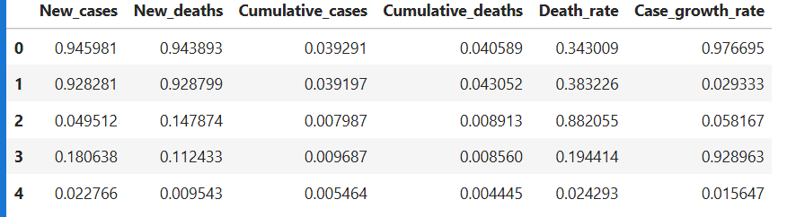

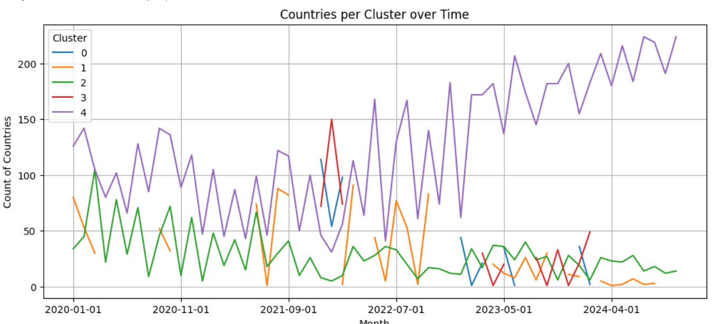
The time 5-cluster analysis shows how Covid-19 progressed across the world, varying by healthcare capacity, data reporting and national response

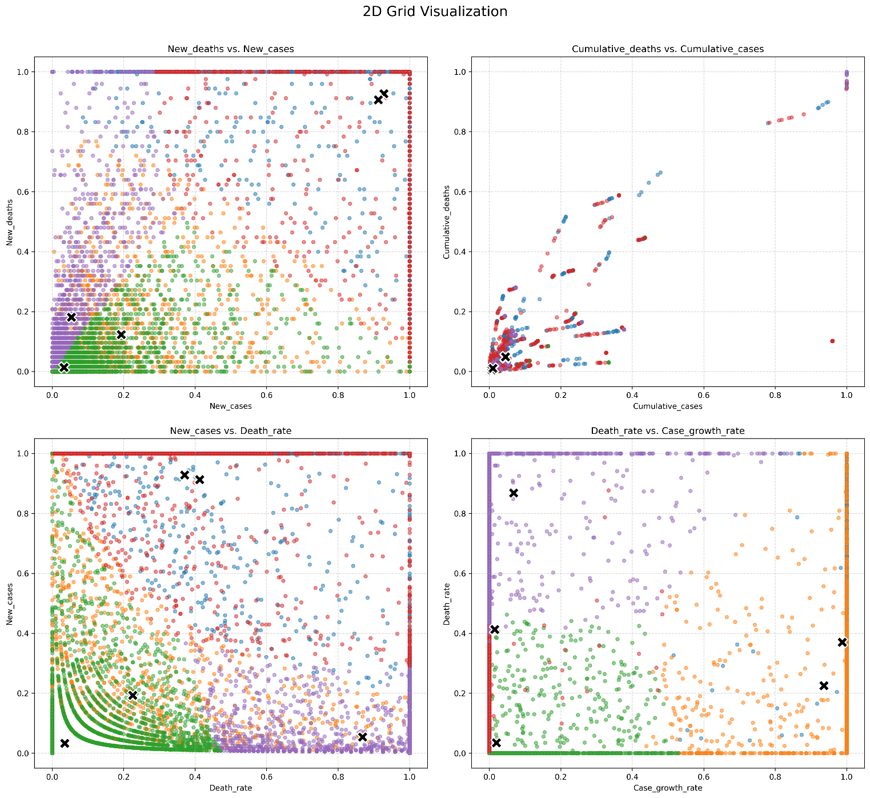
The 2D grid shows how the clusters separate countries based on Covid-19 statistics. Each subplot compares two features. The X symbol shows the cluster centers.

Layoffs

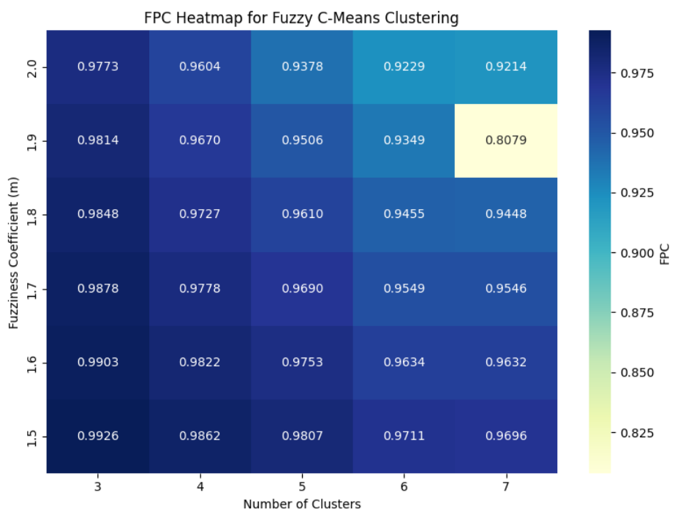
To see the temporal patterns of layoffs across different periods we applied FCM to monthly observations in the dataset. We experimented with fuzziness coefficients from 1.5 to 2 and cluster numbers from 3 to 7 in order to determine the best clustering approach using the FPC score. The results show that for any number of clusters a lower fuzziness coefficient has the best results, indicating that less overlap improves interpretation. The 3-cluster solutions consistently achieved the highest FPC, providing the best partition. Overall the analysis showed that a 3-cluster model with a fuzziness of 1.5 is better and allows us to track temporal shifts and overlapping periods of layoffs. (Paragraph written with the help of generative Ai)

3-clusters and 1.5 fuzziness coefficient

FCM assigned companies to 3 clusters based on layoffs. Based on the top entries per cluster we can interpret them as:

Cluster 0: moderate layoffs across diverse industries, with companies like Indeed, Shopify or Micron and an average layoff count of 2248.63.

Cluster 1: high intensity layoffs in tech and retail, with companies such as Amazon, Microsoft, Meta and Ericsson and average layoff count of 9010

Cluster 2: Low layoffs, representing small-scale events. Companies include Blue Nile, Nomad Health and Miro and the average layoff count is 122.

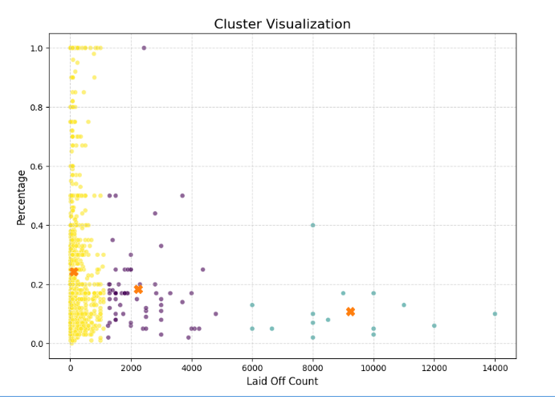

Based on the temporal graph, we can observe that the peak layoff period was between September 2020 and March 2023, with a spike of layoffs for smaller companies at the beginning of the pandemic in early 2020. Cluster 0 has a few layoff significant periods with a moderate count all throughout late 2020 and 2021, while cluster 1 started layoffs only in October 2022.
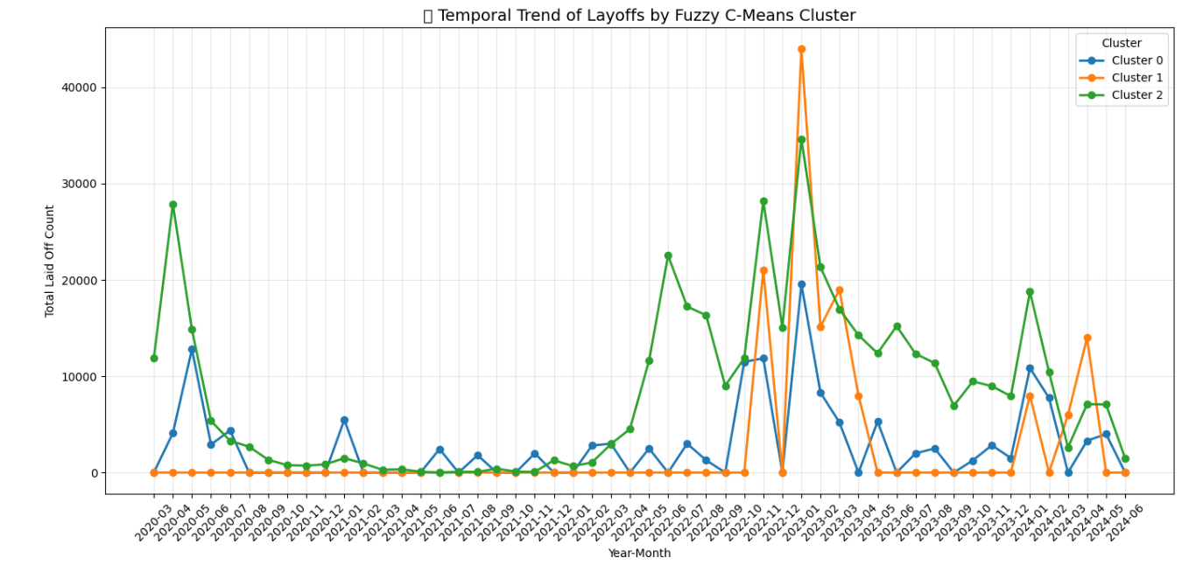

Global logistics and economic indicators

The aim of this analysis is to inspect the relation that different pandemic stages had on worldwide logistics and economy indicators by visualizing the temporal evolution of clusters from 2020 to 2024. The cleaned Global logistics and economic indicators dataset was transposed and we performed FCM clustering with different number of clusters to identify the most accurate partition of data. The FPC score was computed for each experiment to measure clustering quality. The results indicate that the 3 clusters approach is the most accurate reflection of the real world economic phenomenon caused by the pandemic. By using the Year-Month column we can visualize temporal transitions between clusters in order to see how the indicators shifted over time.
For the cleaned dataset we performed FCM using the skfuzzy library with the metrics:
- fuzzification coefficient: 1.5, 1.6, 1.7, 1.8, 1.9, 2,
- maximum iterations: 1000,
- convergence tolerance: 0.005
- varying number of clusters (3,4,5,6, 7)
The heatmap shows the FPC values for each cluster number and fuzziness coefficient combination. The results show that for this dataset the 3-cluster solution produces the highest FPC for all coefficients.

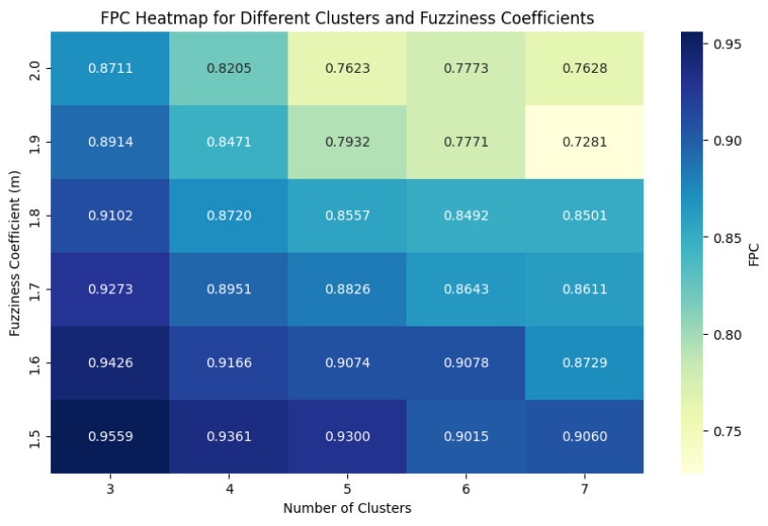
3 clusters and 1.5 fuzziness coefficient

The 3 clusters approach offered the best overview of the pandemic economic stages, splitting the data into:
- Cluster 0: the pre-pandemic period, early 2020 before the global lockdowns
- Cluster 1: pandemic peak
- Cluster 2: initial disruption and recovery

Cluster | Global_Container_Index_FBX | China_US_West_Coast_Route | US_West_  Coast_  China_  Route | China_North_Europe_  Route | North_  Europe_  China_Route | Brent_Oil_Price_  USD
0 | 1920.211371 | 2386.231183 | 452.000000 | 1960.242025 | 476.269789 | 43.517689
1 | 8442.407407 | 9197.437305 | 518.583029 | 6495.891875 | 1498.703015 | 88.153053
2 | 2149.753478 | 2224.580307 | 519.984841 | 6482.429607 | 1498.879883 | 80.576837

We can observe in the Fuzzy membership heatmap how these stages evolved, from the normal economic state to a sudden disruption, a quarantine period and a slow recovery. The fuzzy membership values allow us to see overlaps between clusters, indicating months where the global economy was transitioning between phases.

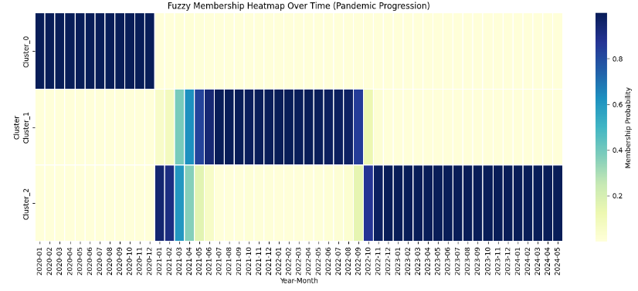

World happiness report

Because FCM allows each country to belong to multiple clusters simultaneously it will help us understand each country's socio-economic status and well-being over time, by identifying clustering patterns in the World Happiness dataset. In the data analysis stage we used the cleaned and scaled features: Happiness score, GDP, social support, healty life expectancy, freedom to make life choices, generosity and perception of corruption. The FCM algorithm was implemented with the skfuzzy Python package and the parameters: fuzzification coefficient from 1.5 to 2, maximum iterations: 1000, convergence tolerance: 0.005 and a varying number of clusters (3,4,5,6,7). The FPC was computed to assess clustering quality.

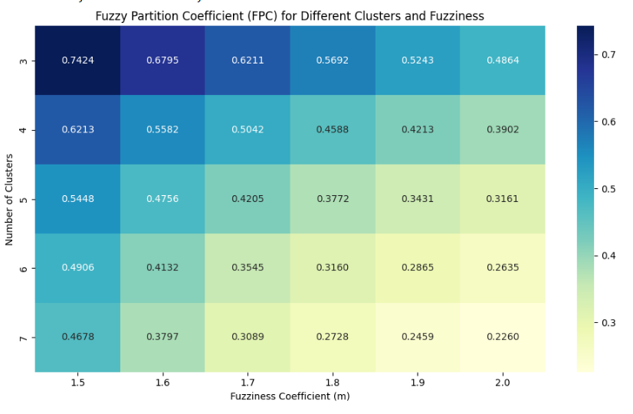
We experimented with multiple values for the fuzziness coefficient and cluster number, using the FPC score to evaluate quality. For any number of clusters, a decrease in the fuzziness coefficient improved the FPC score. This indicates that a lower m separates the clusters better. For this dataset, a small fuzziness coefficient results in more interpretable clusters. The 3 cluster method with m=1.5 was chosen as the best and the results interpreted.

3 clusters and 1.5 fuzziness coefficient

Based on the top countries per cluster based on membership strength, the clusters are:

Cluster | Countries | Description
0 | Burkina Faso, Liberia, Togo, Chad | Lower happiness scores  (0.41-0.56)
1 | Ecuador, Jamaica, Paraguay, Kazakhstan | Medium happiness scores  (0.63-0.72)
2 | Germany, Canada, Austria, UK | High happiness scores  (0.82-0.87)

The FCM algorithm separated countries into clusters according to happiness and socio-economic indicators, while allowing some overlap in membership in order to capture transitional or intermediate states between clusters. The included heatmap shows how each cluster evolved over the 4 pandemic years.
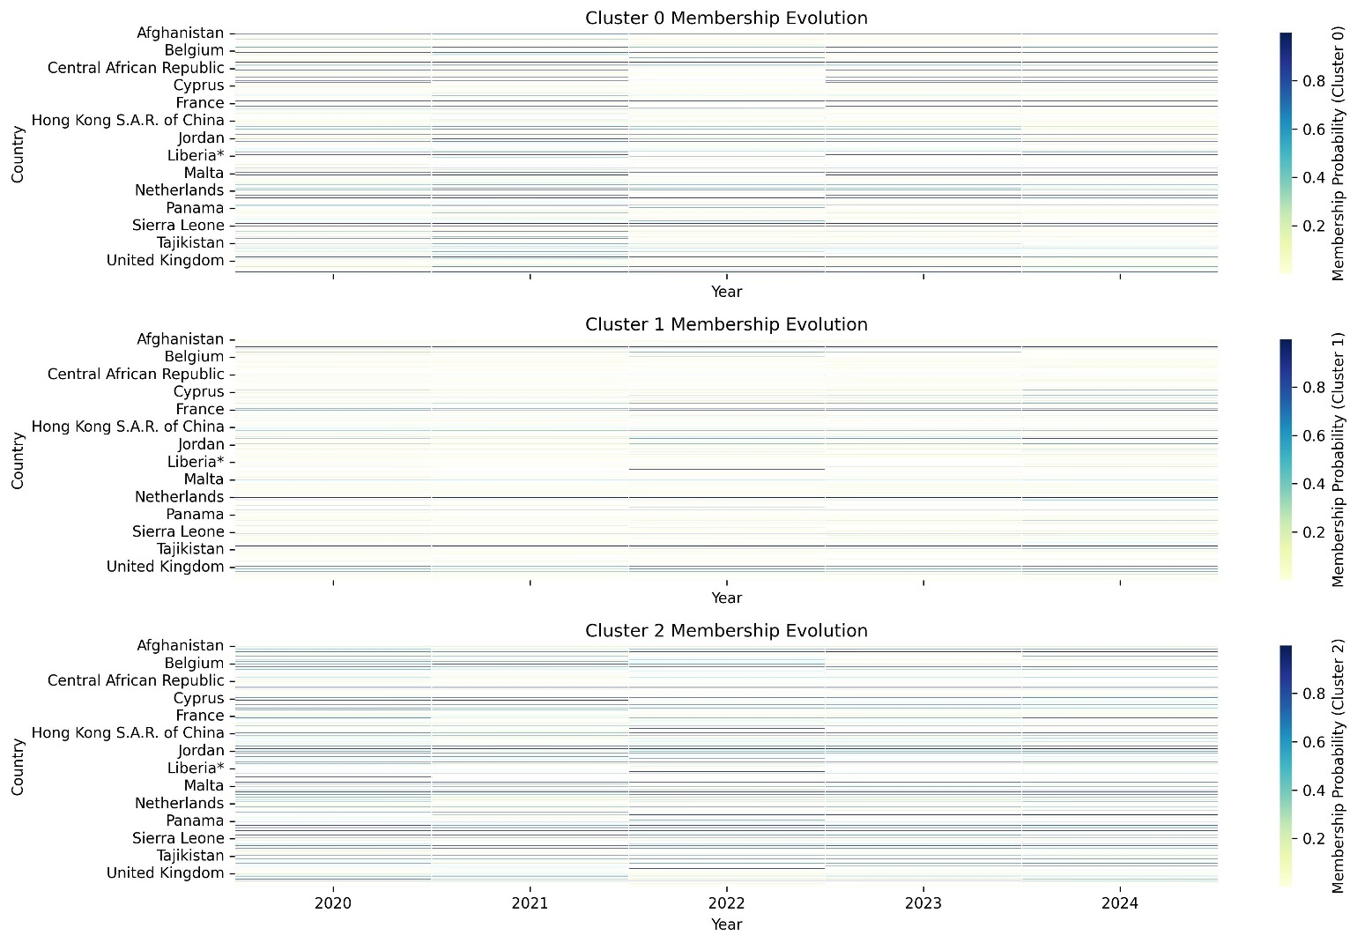
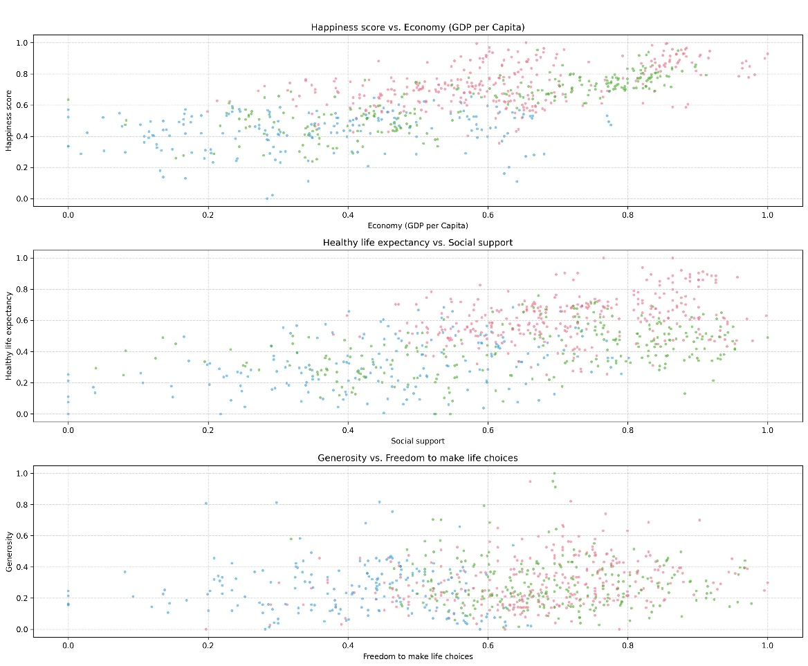

Reporting and evaluation

In this section we compare the results obtained with FCM for the four datasets in the pandemic context, in order to obtain a global overview of how the virus affected multiple aspects of life and their correlation. FCM was chosen because it allows for multiple cluster memberships, reflecting the overlap of real world phenomenon. Across datasets the optimal number of clusters varied, with the Covid-19 data being better separated with 5 clusters and the rest with 3. The fuzzification coefficient used was 1.5 for all. While lower fuzziness coefficients resulted in higher FPC in these experiments, excessively low values may reduce the model’s ability to capture soft transitions.

Covid 19
The first dataset was made up of daily virus statistics across all countries, which we aggregated in order to obtain monthly statistics for new and cumulative cases and deaths. The experiments were performed with varying clusters and fuzziness coefficients, out of which the 5-cluster model was selected. This solution captured real-world transitions caused by vaccination, virus variants and national policies.

Layoffs
This dataset, obtained by scrapping Layoffs.fyi was used to track monthly layoffs across global companies. FCM was applied with 3 to 7 clusters and varying fuzziness. The chosen method, 3 clusters with a fuzziness coefficient of 1.5, revealed that peak layoffs occurred between September 2020 and March 2023, with an early spike in smaller companies in early 2020, while larger firm’s layoffs occurred later.

Global Logistics and Economic Indicators
The FCM results on the global logistics and economic indicators dataset revealed three economic stages during the pandemic: pre-pandemic, peak and initial disruption and recovery. FCM was important because it helped provide a transitional view.

World Happiness Analysis
This dataset holds yearly scores for happiness, GDP, social support, life expectancy etc. for each country. FCM experiments resulted in the 3-cluster solution with 1.5 fuzziness as the best. The clusters separated countries by socio-economic resources and well-being.

Cross-Data Observations
We used temporal heatmaps and graphs on all results to show the evolution of cluster membership across the four years. We can observe on the Covid-19 heatmap and the Layoffs graph that the shift from before the pandemic to the beginning of the virus in December 2020 corresponds with a small wave of layoffs across different industries and that the September 2022 recovery corresponds with multiple layoffs across all sectors. Economic disruptions align with pandemic peaks, but recovery trajectories vary. Happiness clusters only show subtle shifts corresponding to the after-effects of the main layoff wave and the peak of the pandemic.

Methodology
FCM handles overlaps and transitions effectively and the temporal evolution of clusters is easy to visualize, but is sensitive to parameter selection and too many clusters reduce interpretability.

Conclusions

This analysis demonstrates that the global impact of Covid-19 was influenced by a multitude of factors. Virus progression varied across countries because of differences in healthcare and testing capacity, as well as political response. Layoffs showed distinct peaks that align with different stages of the pandemic, but the patterns differ based on company size and industry sector. Economic indicators showed clear phases of disruption and recovery, while happiness showed a correlation the peak of the pandemic. The fuzzy clustering method captured variations, highlighting distinct pandemic trajectories and overlapping periods, such as the uneven economic recovery and varying pandemic intensities.

In conclusion, the study confirms that fuzzy c-means clustering provides insights into overlapping phenomena because it captures transitions. Because data can belong to multiple clusters, FCM is better suited to temporal analysis than hard clustering methods. Future work could include incorporating additional socio-economic and health indicators.

References
Balasko, B. A. (2005). Fuzzy clustering and data analysis toolbox. Veszprem.: Department of Process Engineering, University of Veszprem.
Döring, C. L. (2006). Data analysis with fuzzy clustering methods. Computational Statistics & Data Analysis, 192-214.
Ghosh, S. &. (2013). Comparative analysis of k-means and fuzzy c-means algorithms. International Journal of Advanced Computer Science and Applications.
Lund, B. &. (Performance Measurement and Metrics). 2021. A review of cluster analysis techniques and their uses in library and information science research: k-means and k-medoids clustering., 161-173.
Nascimento, S. M.-P. (2000). A fuzzy clustering model of data and fuzzy c-means. Ninth IEEE International Conference on Fuzzy Systems. FUZZ-IEEE 2000, 302-307.

